1. Register
2. Register request

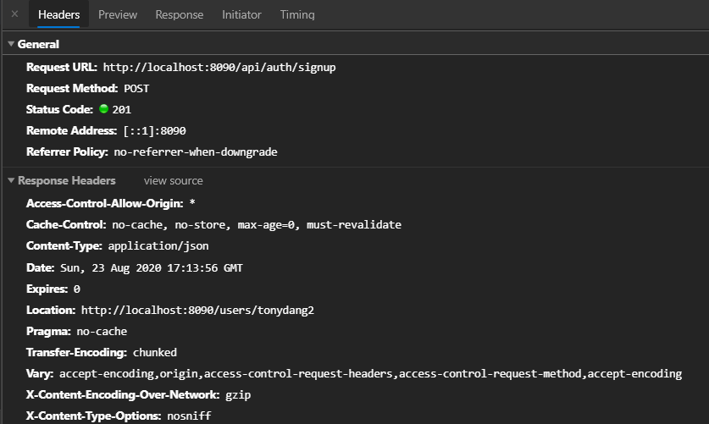

Response

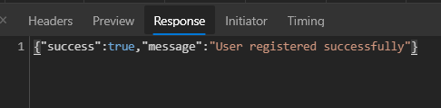

1. Check email availability request

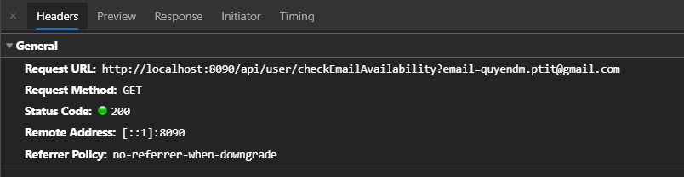

Response

false

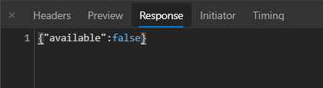

true

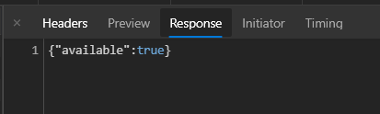

1. Check username availability request

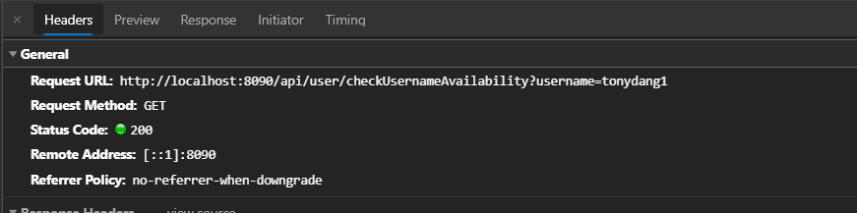

Response

false



true



1. Login
2. Login request

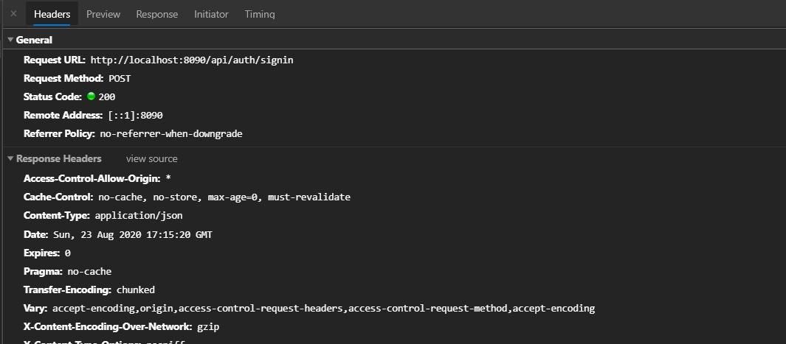

Login Response



1. Get current user request

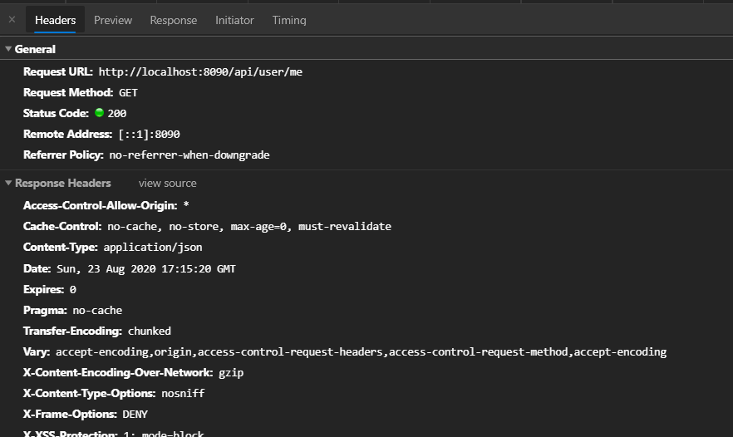

Response

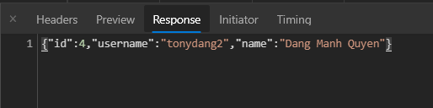

1. Dashboard (Product search)
2. When open the screen after logged in, get all products request

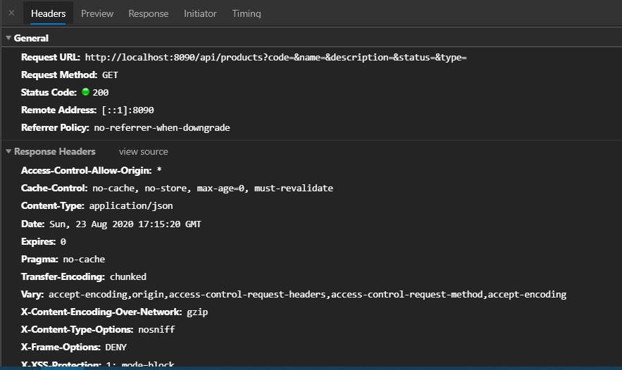

Response

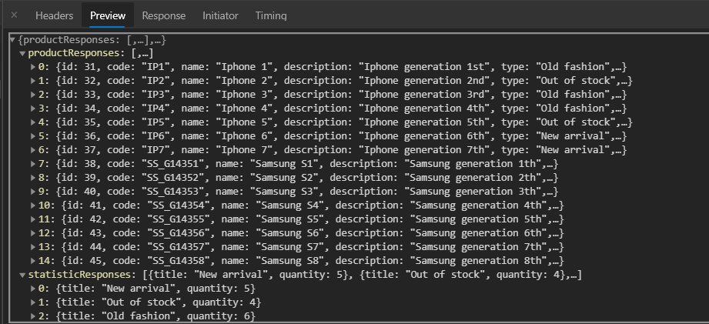

1. Fill the search form and click button Apply

Request

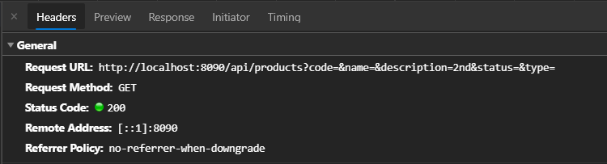

Response

